EXPERIMENT 23

DSP-Based Image Enhancement, Compression and Edge Detection Using MATLAB
DSP LABORATORY RECORD

Name: Lokesh A (192512293)
Programme: B.E. Electronics and Communication Engineering (ECE)
Date: 13 October 2026

1. AIM
To perform image enhancement, JPEG image compression and edge detection using MATLAB, and to evaluate the processed images using MSE, PSNR, normalized image error, SSIM, compression ratio and edge-pixel count.

2. SOFTWARE REQUIRED
- MATLAB
- Image Processing Toolbox
- Input image: cameraman.tif (grayscale sample image, 256 × 256 pixels in the observed run)

3. THEORY
Image enhancement improves the visual contrast of an image. A 3 × 3 median filter replaces each pixel with the median of its neighbourhood and can reduce impulse-like noise while preserving many edges. Contrast stretching with imadjust expands the useful intensity range.
JPEG compression reduces image storage requirements by encoding image information with losses. The quality factor controls the trade-off between image quality and compression. A lower quality usually gives a smaller file and lower PSNR; a higher quality usually gives a larger file and higher PSNR.
The Canny edge detector identifies image boundaries using gradient information and thresholding. MSE measures pixel-wise reconstruction error, PSNR expresses reconstruction quality in decibels, and SSIM measures structural similarity. Compression ratio is the original file size divided by the compressed file size.

4. FORMULAE
Mean Square Error (MSE): MSE = (1/N) Σ [I(i) − Î(i)]²
Peak Signal-to-Noise Ratio (PSNR): PSNR = 10 log₁₀(MAX² / MSE)
Normalized Image Error (NIE): NIE = MSE / MAX²
Compression Ratio (CR): CR = Original image size / Compressed image size
Bits per pixel (bpp): bpp = 8 × Compressed size in bytes / Number of pixels

5. PROCEDURE
- Load cameraman.tif and convert it to grayscale if it is an RGB image.
- Apply a 3 × 3 median filter to the input image.
- Enhance contrast using imadjust and stretchlim.
- Compress the original image as JPEG with quality factor 50, then read the reconstructed image.
- Apply Canny edge detection to the original, enhanced and JPEG-reconstructed images.
- Calculate MSE, PSNR, normalized image error, SSIM, compression ratio and bits per pixel.
- Repeat JPEG compression for quality values 10 to 90 and plot PSNR and compression ratio against quality.
- Inspect the output figures and record the values printed in the MATLAB Command Window.

6. MATLAB PROGRAM
%% EXPERIMENT 23
% DSP-Based Image Enhancement, Compression and Edge Detection Using MATLAB
% Input: cameraman.tif (256 x 256 grayscale sample image)
% Processing: median filtering, contrast stretching, JPEG compression, Canny edges
% Required toolbox: Image Processing Toolbox

clc;
clear;
close all;

%% 1. INPUT PARAMETERS
imgName = 'cameraman.tif';
medSize = [3 3];
jpegQuality = 50;
cannyTh = [0.1 0.2];
MAXI = 255;

%% 2. LOAD INPUT IMAGE (ROBUST SEARCH)
% Search the current folder and MATLAB path first.
imgPath = '';

if isfile(imgName)
imgPath = imgName;
else
foundPath = which(imgName);
if ~isempty(foundPath) && isfile(foundPath)
imgPath = foundPath;
end
end

% Try MATLAB's standard sample-image location, if available.
if isempty(imgPath)
candidate = fullfile(matlabroot, 'toolbox', 'images', 'imdata', imgName);
if isfile(candidate)
imgPath = candidate;
end
end

% If not found, stop with a useful message before later calculations.
if isempty(imgPath)
error(['Cannot find %s. Upload cameraman.tif to the same folder as this script ' ...
'in MATLAB Drive, then run the script again.'], imgName);
end

I = imread(imgPath);

if size(I, 3) == 3
I = rgb2gray(I);
end
if ~isa(I, 'uint8')
I = im2uint8(I);
end

[rows, cols] = size(I);
fprintf('============================================================\n');
fprintf(' EXPERIMENT 23: IMAGE ENHANCEMENT, COMPRESSION AND EDGE DETECTION\n');
fprintf('============================================================\n');
fprintf('Image file : %s\n', imgPath);
fprintf('Image size : %d x %d\n', rows, cols);
fprintf('Image class : %s\n', class(I));
fprintf('Minimum intensity : %d\n', min(I(:)));
fprintf('Maximum intensity : %d\n', max(I(:)));
fprintf('Mean intensity : %.2f\n', mean(double(I(:))));
fprintf('Std. deviation : %.2f\n', std(double(I(:))));

%% 3. MEDIAN FILTERING AND CONTRAST ENHANCEMENT
I_med = medfilt2(I, medSize);
I_enh = imadjust(I_med, stretchlim(I_med), []);

%% 4. JPEG COMPRESSION AND RECONSTRUCTION
jpgFile = fullfile(tempdir, 'cameraman_q50.jpg');
imwrite(I, jpgFile, 'jpg', 'Quality', jpegQuality);
I_rec = imread(jpgFile);

origBytes = numel(I); % 8-bit grayscale image: 1 byte per pixel
jpgInfo = dir(jpgFile);
compBytes = jpgInfo.bytes;
CR = origBytes / compBytes;
bpp = 8 * compBytes / numel(I);

%% 5. CANNY EDGE DETECTION
E_orig = edge(I, 'canny', cannyTh);
E_enh = edge(I_enh, 'canny', cannyTh);
E_rec = edge(I_rec, 'canny', cannyTh);

%% 6. IMAGE QUALITY METRICS
% PSNR is infinite when the images are identical (MSE = 0).
MSE = @(A,B) mean((double(A(:)) - double(B(:))).^2);
PSNR = @(A,B) localPSNR(MSE(A,B), MAXI);

MSE_med = MSE(I, I_med);
PSNR_med = PSNR(I, I_med);

MSE_enh = MSE(I, I_enh);
PSNR_enh = PSNR(I, I_enh);

MSE_rec = MSE(I, I_rec);
PSNR_rec = PSNR(I, I_rec);

NIE_med = MSE_med / MAXI^2;
NIE_enh = MSE_enh / MAXI^2;
NIE_rec = MSE_rec / MAXI^2;

SSIM_rec = ssim(I_rec, I);
edgePix = [nnz(E_orig), nnz(E_enh), nnz(E_rec)];

%% 7. FIGURE 23A: IMAGE PROCESSING RESULTS
figure('Name', 'Experiment 23A: Image Processing Results', ...
'Color', 'w', 'Position', [40 40 1200 750]);

subplot(2,3,1);
imshow(I);
title('Original image');

subplot(2,3,2);
imshow(I_med);
title('After 3 x 3 median filter');

subplot(2,3,3);
imshow(I_enh);
title('Enhanced (median + imadjust)');

subplot(2,3,4);
imshow(I_rec);
title(sprintf('JPEG Q=%d reconstructed (CR = %.2f)', jpegQuality, CR));

subplot(2,3,5);
imshow(E_orig);
title('Canny edge map (original)');

subplot(2,3,6);
imshow(E_rec);
title('Canny edge map (JPEG reconstructed)');

%% 8. FIGURE 23B: HISTOGRAMS
figure('Name', 'Experiment 23B: Histograms', ...
'Color', 'w', 'Position', [80 80 900 350]);

subplot(1,2,1);
imhist(I);
title('Histogram - original');

subplot(1,2,2);
imhist(I_enh);
title('Histogram - enhanced');

%% 9. FIGURE 23C: COMPRESSION ERROR AND ENHANCED EDGES
figure('Name', 'Experiment 23C: Compression Error and Enhanced Edges', ...
'Color', 'w', 'Position', [120 120 900 380]);

subplot(1,2,1);
imshow(abs(double(I) - double(I_rec)), []);
colorbar;
title('|Original - JPEG reconstructed|');

subplot(1,2,2);
imshow(E_enh);
title('Canny edge map (enhanced image)');

%% 10. FIGURE 23D: JPEG RATE-DISTORTION ANALYSIS
qList = 10:10:90;
psnrQ = zeros(size(qList));
crQ = zeros(size(qList));

for k = 1:numel(qList)
tempJpg = fullfile(tempdir, sprintf('cameraman_q%d.jpg', qList(k)));
imwrite(I, tempJpg, 'jpg', 'Quality', qList(k));

I_temp = imread(tempJpg);
tempInfo = dir(tempJpg);

psnrQ(k) = PSNR(I, I_temp);
crQ(k) = origBytes / tempInfo.bytes;
end

figure('Name', 'Experiment 23D: JPEG Rate-Distortion', ...
'Color', 'w', 'Position', [160 160 900 380]);

subplot(1,2,1);
plot(qList, psnrQ, '-o', 'LineWidth', 1.4);
grid on;
xlabel('JPEG quality');
ylabel('PSNR (dB)');
title('PSNR vs JPEG quality');

subplot(1,2,2);
plot(qList, crQ, '-s', 'LineWidth', 1.4);
grid on;
xlabel('JPEG quality');
ylabel('Compression ratio');
title('Compression ratio vs JPEG quality');

%% 11. OUTPUT PARAMETER TABLE
fprintf('\n================ OUTPUT PARAMETER TABLE ================\n');
fprintf('%-28s %12s %12s %14s\n', ...
'Image', 'MSE', 'PSNR (dB)', 'MSE/MAXI^2');
fprintf('%s\n', repmat('-', 1, 70));
fprintf('%-28s %12.2f %12.2f %14.6f\n', ...
'Median filtered', MSE_med, PSNR_med, NIE_med);
fprintf('%-28s %12.2f %12.2f %14.6f\n', ...
'Enhanced (imadjust)', MSE_enh, PSNR_enh, NIE_enh);
fprintf('%-28s %12.2f %12.2f %14.6f\n', ...
sprintf('JPEG Q=%d reconstructed', jpegQuality), MSE_rec, PSNR_rec, NIE_rec);

fprintf('\n--- Compression results (JPEG Q = %d) ---\n', jpegQuality);
fprintf('Original size : %d bytes\n', origBytes);
fprintf('Compressed size : %d bytes\n', compBytes);
fprintf('Compression ratio : %.2f : 1\n', CR);
fprintf('Bits per pixel : %.3f bpp\n', bpp);
fprintf('SSIM (JPEG vs original): %.4f\n', SSIM_rec);

fprintf('\n--- Edge detection (Canny [%.1f %.1f]) ---\n', cannyTh(1), cannyTh(2));
fprintf('Edge pixels - original image : %d\n', edgePix(1));
fprintf('Edge pixels - enhanced image : %d\n', edgePix(2));
fprintf('Edge pixels - JPEG reconstructed : %d\n', edgePix(3));

fprintf('\n--- JPEG rate-distortion results ---\n');
fprintf('%12s %14s %20s\n', 'Quality', 'PSNR (dB)', 'Compression ratio');
for k = 1:numel(qList)
fprintf('%12d %14.2f %20.2f\n', qList(k), psnrQ(k), crQ(k));
end

fprintf('\nRESULT: Image enhancement, JPEG compression and edge detection completed.\n');
fprintf('============================================================\n');

%% LOCAL FUNCTION
function value = localPSNR(mseValue, peakValue)
if mseValue == 0
value = Inf;
else
value = 10 * log10((peakValue^2) / mseValue);
end
end

7. OUTPUT FIGURES
Figure 1: Original image, median-filtered image, enhanced image, JPEG reconstruction and Canny edge maps.
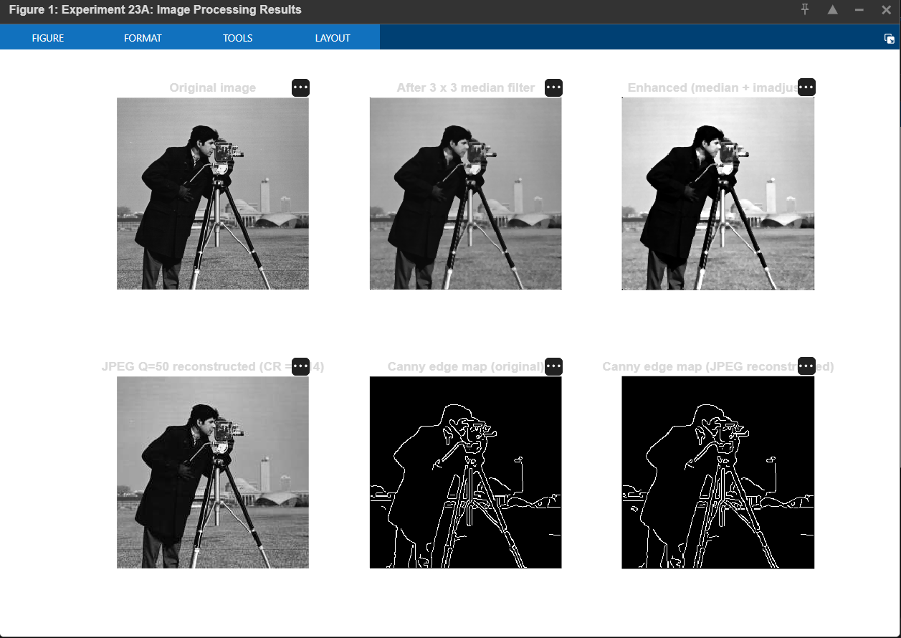

Figure 2: Intensity histograms of the original and enhanced images.
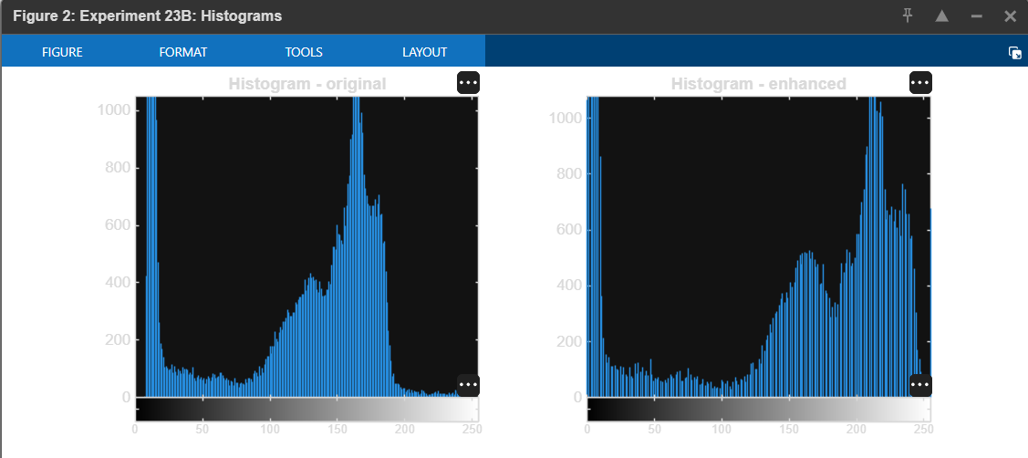

Figure 3: JPEG reconstruction error image and edge map of the enhanced image.
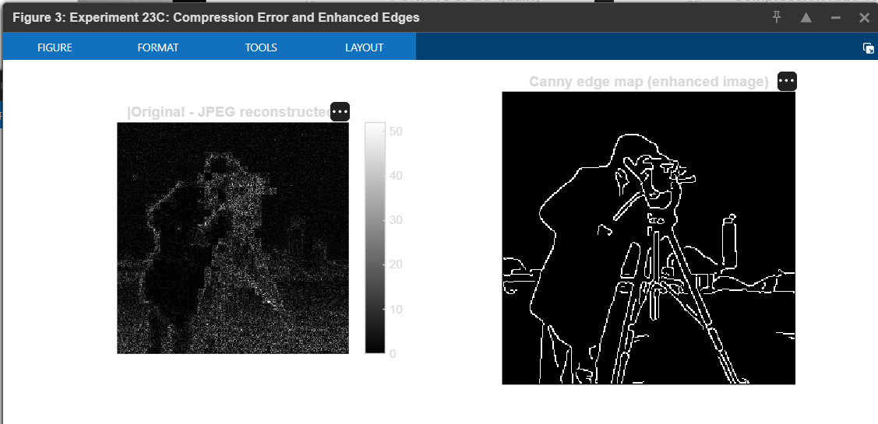

Figure 4: PSNR and compression ratio versus JPEG quality.
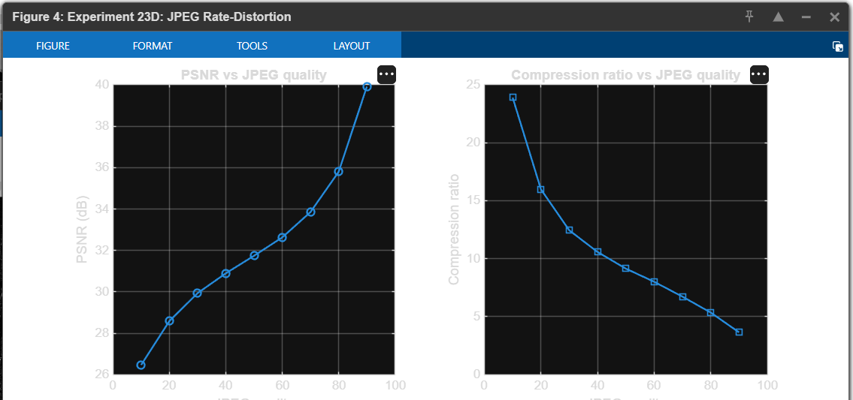

Figure 5: MATLAB Command Window output and calculated performance metrics.
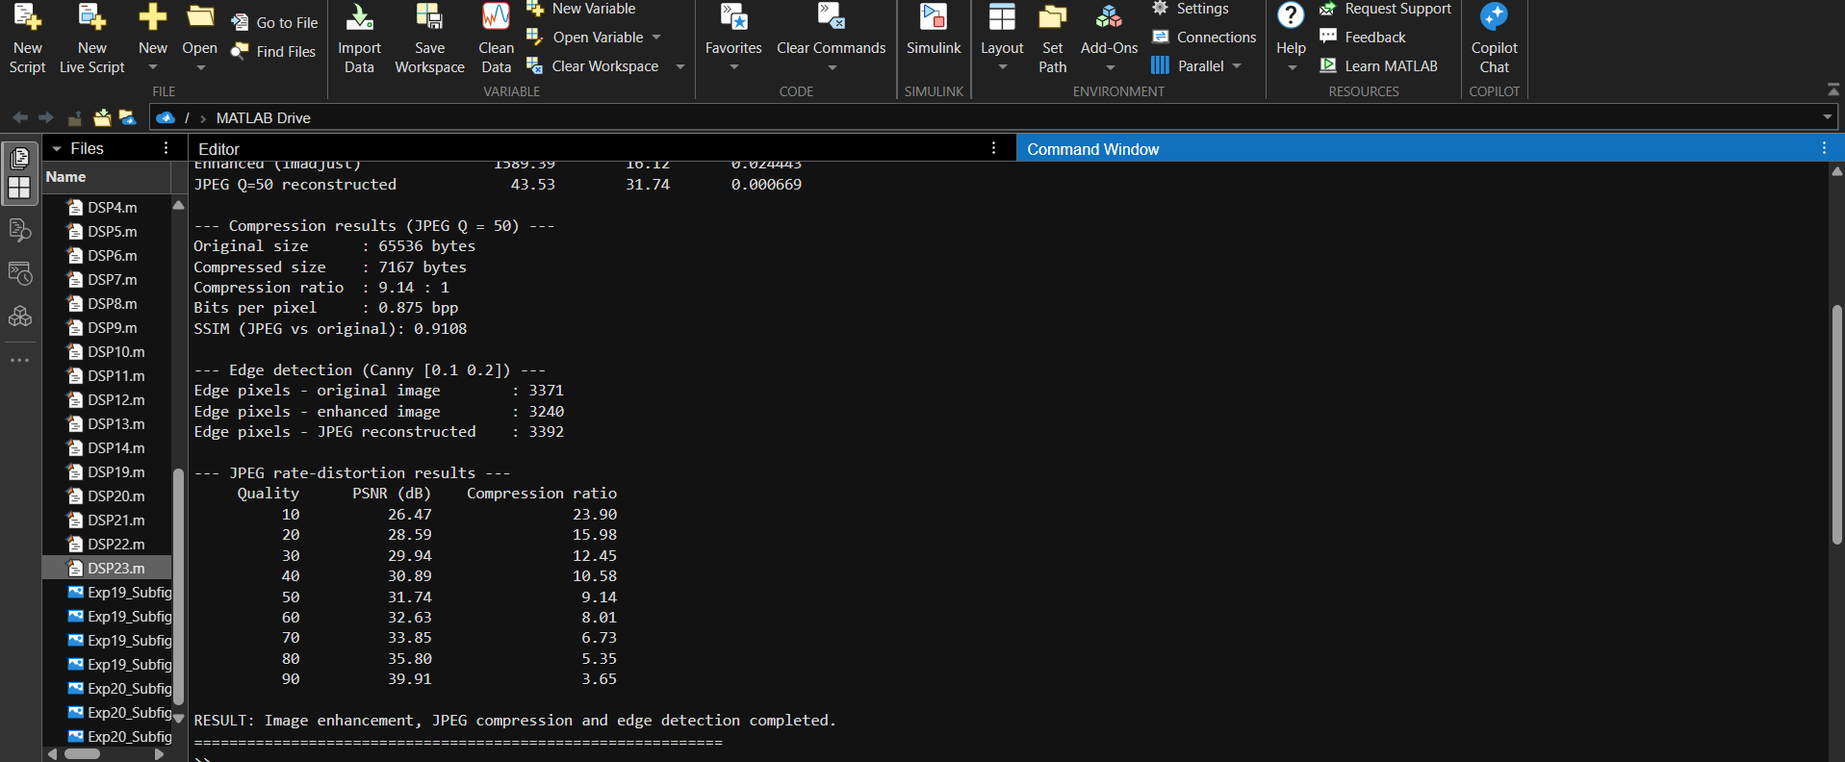

8. OBSERVED RESULTS
The MATLAB run shown in the supplied screenshots produced the following JPEG quality-50 results. Values may vary slightly if the image file, MATLAB version or compression implementation differs.
Parameter | Observed value
Input image | cameraman.tif, 256 × 256, uint8
Intensity range | Minimum = 7; Maximum = 253
Mean / standard deviation | 118.72 / 62.34
Median-filtered MSE | 123.61
Median-filtered PSNR | 27.21 dB
Enhanced-image MSE | 1589.39
Enhanced-image PSNR | 16.12 dB
JPEG Q=50 MSE | 43.53
JPEG Q=50 PSNR | 31.74 dB
Original image size | 65,536 bytes
Compressed image size | 7,167 bytes
Compression ratio | 9.14 : 1
Bits per pixel | 0.875 bpp
SSIM (JPEG vs original) | 0.9108
Canny edge pixels: original / enhanced / JPEG | 3371 / 3240 / 3392

9. INFERENCE
The median filter smoothed the image, while contrast stretching made the visual contrast more pronounced. JPEG quality 50 reduced the image size from 65,536 bytes to 7,167 bytes, giving a compression ratio of approximately 9.14:1. The reconstructed JPEG image had a PSNR of 31.74 dB and SSIM of 0.9108 in the shown run. The rate-distortion plot showed that PSNR increased with JPEG quality, while compression ratio decreased as the compressed file became larger.

10. RESULT
Image enhancement, JPEG compression and Canny edge detection were implemented successfully in MATLAB. The processed images were visualized and their quality and compression performance were evaluated using MSE, PSNR, normalized image error, SSIM, compression ratio and edge-pixel count.

